

NORTH SOUTH UNIVERSITY

Department of Electrical & Computer Engineering (ECE)

CSE499B SENIOR DESIGN II

Section: 11

Faculty: DR. MOHAMMAD ASHRAFUZZAMAN KHAN (AZK)



**Project Title: Precise Control Drone**

***Modern Analysis and Design Tools***



Submitted By:

|  |  |
| --- | --- |
| Name | ID |
| Shuvashish Chakraborty | 2012875042 |
| Tasnia Afsar Ifti | 2012605642 |
| Biswajit Chandra Das | 1921685642 |

Date of Submission: 01-04-2024



*For Instructor’s use only*

|  |  |
| --- | --- |
| SCORE: | REMARKS: |
|
|  |  |
|  |  |
|  |  |
|  |  |
| PENALTY: |  |
|  |
|  |  |

**Modern Analysis and Design Tools**

In the era of modern science and technology, the development and use of precise-controlled drones are increasing exponentially across various industries because they offer unparalleled accuracy, diverse functionality, and enhanced efficiency.

We have used multiple design and analysis tools to design this precise controlled drone.

1. **EasyEDA:**

We have used EasyEDA standard edition for our PCB (printed circuit board) design and schematic design. This is a free, web-based Electronic Design Automation (EDA) tool. This is available for hardware engineers to design, share publicly and privately, simulate, and discuss simulations, schematics, and printed circuit boards.

First, we prepared a rough circuit diagram with all electrical components, IC, sensors, and connectors. Then, we designed the schematic in EasyEDA by following the circuit diagram. We searched for components in the LCSC Electronics library and imported the necessary components required for the design. Then, we wired the components following the circuit diagram. The unconnected pins were connected with no connect flag. The schematic diagram is ready for further use.

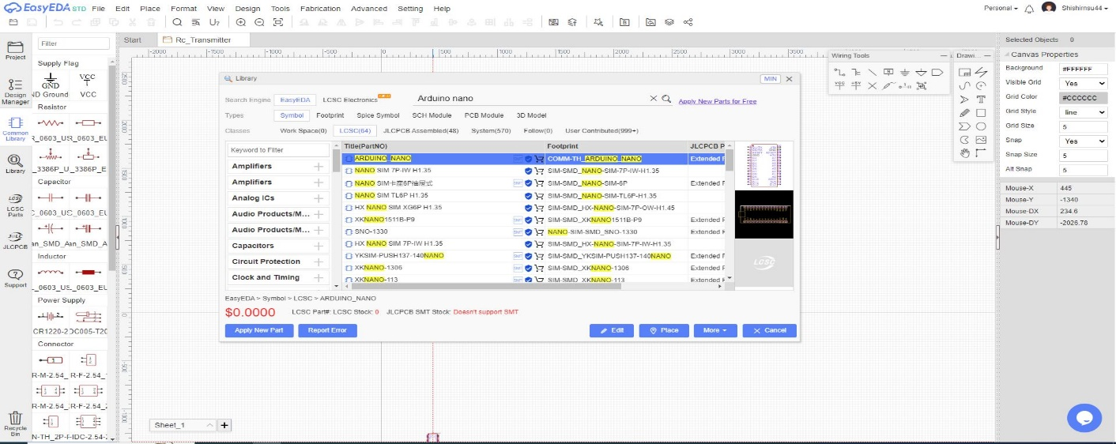After the schematic diagram was ready, we performed debugging the schematic using design rule checker (DRC). Then, we converted the schematic into PCB. In the PCB layout, we arranged the components and labeled them accordingly. Then, we inserted mounting holes in the PCB layout. Then, we checked the 3D view of our circuit and checked that everything fit in the right place. In the last step, we exported our design in Garber file format.

***Figure: The user interface of EasyEDA tool***

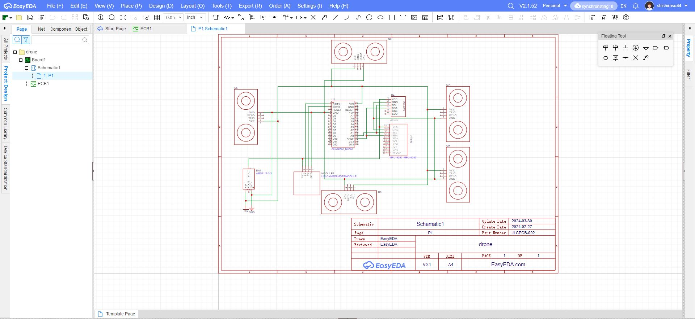The user interface of EasyEDA is simple, and it provides all the functionality required for schematic design. Another essential thing in this tool is the library of components or the LCSC Electronics library. This library contains billions of electrical components and sensors. So, it is easy to find and place the component in schematic design. The part view, circuit view, and footprint also help in finding the exact component.

***Figure: Flight Controller Schematic design using EasyEDA***

This tool also allows multiple users to work on the same project simultaneously. So, collaboration among team members becomes easy. This is a hardware-based project. So, designing schematics and PCBs is an essential part of our project. This tool helped us to design the circuit easily and quickly. So, it was a lifesaver for us.

**Arduino IDE**:

We have used Arduino IDE to program the flight controller, radio transmitter, radio receiver, and object detection circuit. It is an open-source software. We can write and upload code to the Arduino boards with this IDE. This IDE is applicable to a wide range of operating systems such as Windows, Linux, Mac OS, etc. The code written on this IDE is called a Sketch. Then, we can verify our code and upload it to the selected Arduino board. This is a powerful code editor with syntax highlighting and auto-completion features that assist us in writing and editing code.

Another essential feature is the library manager of this IDE. The library manager helps in downloading and installing the required library used for the project. In this project, we have used NewPing.h, wire.h, servo.h, fastLED.h, SPI.h, nrf21L01.h, etc. library in our project. These libraries helped us to write the code more efficiently.

It also provides some additional functionalities and support for various sensors, actuators, and communication protocols.

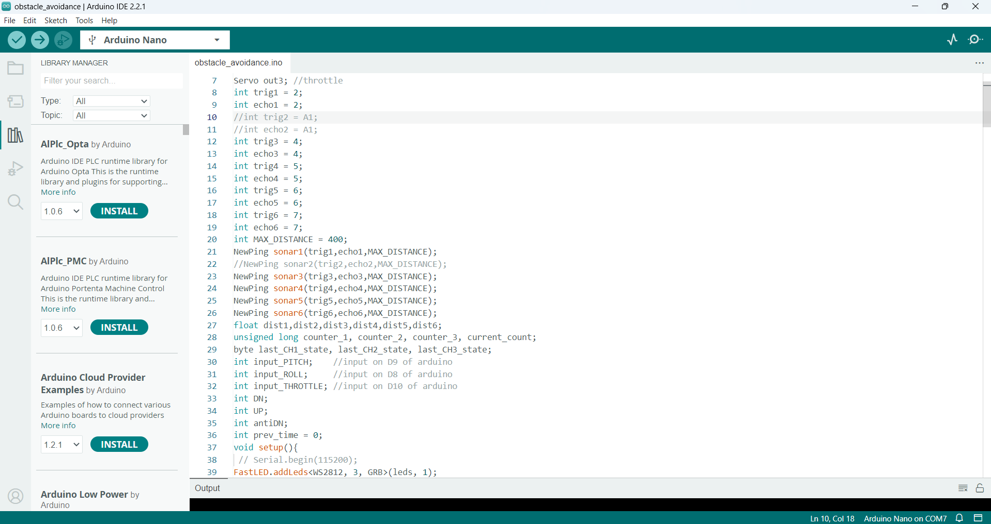The “Verify Sketch” feature of this IDE helps in the verification of the program. It also shows an error if there is any issue in the code. The board manager also helps in selecting and uploading code to any Arduino board with a simple USB connection.

***Figure: Obstacle Avoidance Code in Arduino IDE***

This Arduino IDE is also life-saving for us. Its simplicity helped us to write and upload code easily and efficiently.

**Visual Studio Code:**

We use VS code to debug our code. It is a free, open-source code editor developed by Microsoft. It supports debugging, syntax highlighting, intelligent code completion, snippets, code refactoring, and embedded Git. Arduino IDE does not provide the necessary debugging facility. VS code helps us to overcome this problem. This is another life-saving tool for us.